Comcast Write Up

Below is the trend chart for the number of complaints at the monthly and daily granularity levels.

Monthly:

Daily (for the purposes of this write-up, only 15 lines of this chart is displayed):

Below is the frequency table of complaint types. The maximum complaints were Comcast internet with 18 complaints and the Comcast data cap with 17 complaints.

The maximum complaints by state are shown in the chart below. As shown, Georgia has the most complaints out of all states.

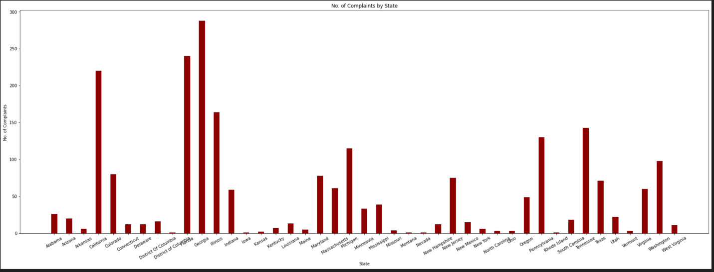

The chart below shows the percentage of unresolved complaints across all states. As can be seen in the chart, Kansas has the highest percentage of unresolved complaints.

Throughout all the complaints received in total, 76.8% of all complaints were resolved or closed, and there are 23.2% still open.

